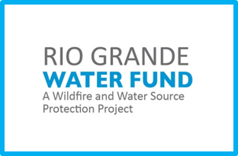 | Thursday, October 15, 2020  9:00 AM – 11:45 AM  Rio Grande Water Fund Signatories Event  via ZOOM  Registration link here
9:00 – 9:30 AM | Welcome, 2020 Updates  - Susan Millsap, The Nature Conservancy, Conservation Director  - U.S. Senator Tom Udall  - Sandy Watts, United States Forest Service, Acting Deputy Regional Forester, Southwestern Region
9:30 – 10:20 AM | Keynote Presentations  - Louise Stafford, The Greater Cape Town Water Fund, Spatial Action Mapping  - Stefanie Woodward, Facebook, Sustainability Program Manager, Water and Climate
10:20 – 10:30 AM | Break
10:30 – 11:15 AM | 2020 Stories from the Field  - State of the Rio Grande Watershed – Steve Bassett, The Nature Conservancy  - Upland Stream Restoration – Reid Whittlesey, Rio Grande Return  - New Frontiers in Spotted Owl Science – Gavin M. Jones, Ph.D., U.S. Forest Service  - Expanding the Use of Prescribed Fire – Laura McCarthy, New Mexico State Forestry
11:15 | Thank you
11:20-11:45 | Optional Breakout Sessions (*TNC Staff)  - Upland Stream Restoration – Reid Whittlesey, *Melissa McLamb  - New Frontiers in Spotted Owl Science – Gavin Jones, *Susan Millsap  - Expanding the Use of Prescribed Fire Across New Mexico – Laura McCarthy, *Anne Bradley, *Nina Carranco  - Water Fund Corporate Engagement: An Investor’s Perspective – Stefanie Woodward, *Jacquelyn Hall  - State of the Watershed & General Discussion – *Collin Haffey, *Aaron Jones  - RGWF Benefit to Wildlife – *Sarah Hurteau, *Sallie Hoefer

